


Curiosity, Courage, Compassion
‘A community learning together in God’s love’

Thundridge and Tonwell St Mary’s Church Schools’ Federation

Calculations Policy
(Tonwell St Mary’s)

Date updated: September 2023
Review Date: September 2024

.

Written Calculation Progression

At Tonwell St Mary’s, we have chosen to adopt the Herts for Learning (HfL) ESSENTIALmaths pathway as outlined in our maths intent document. This policy aims to illustrate our school’s approach to teaching calculations and is linked to the required written formal calculation methods as outlined in the National Curriculum (2013) Mathematics Appendix 1: Examples of formal written methods for addition, subtraction, multiplication and division.
The HfL ESSENTIALmaths Written Calculation Progression links the key concrete experiences with pictorial and abstract representations (written symbolic and spoken). This supports pupils to move with confidence and deep conceptual understanding through each strand of calculation.

Concrete, Pictorial and Abstract

Concrete manipulatives
Concrete manipulatives are objects that can be touched and moved by pupils to introduce, explore or reinforce a mathematical concept. They provide a vehicle to help pupils make sense of complex, symbolic and abstract ideas through exploration and manipulation.
Furthermore, they support the development of internal models and help build stronger memory pathways.
Pictorial (including jottings)
The act of translating the concrete experience into a pictorial representation helps focus attention on what has happened and why. This supports deeper understanding and a stronger imprint on memory. Pictorial representations are more malleable than concrete resources and, once understanding is secured, allow exploration of complex problems that may be challenging to reproduce with manipulatives.
Abstract - Written
The aim, within this policy, is for compacted forms of notation. These have developed through the history of mathematics. Explicit individual steps in procedure are hidden or they have been shortcut. The informal and expanded methods expose all the intermediate steps, replicating thought processes more closely and support understanding prior to compaction.
Abstract - Spoken
Learning to use the correct mathematical vocabulary is vital for the development of mathematical proficiency. The ability to articulate accurately allows pupils to communicate and build meaning. Ideas become more permanent. This can be scaffolded effectively using speaking frame.

EYFS | Early Learning Goals (ELG):  Number  Children at the expected level of development will:  - Have a deep understanding of number to 10, including the composition of each number;  - Subitise (recognise quantities without counting) up to 5;  - Automatically recall (without reference to rhymes, counting or other aids) number bonds up to 5 (including subtraction facts) and some number bonds to 10, including double facts. |  | Numerical Patterns  Children at the expected level of development will:  - Verbally count beyond 20, recognising the pattern of the counting system;  - Compare quantities up to 10 in different contexts, recognising when one quantity is greater than, less than or the same as the other quantity;  - Explore and represent patterns within numbers up to 10, including evens and odds, double facts and how quantities can be distributed equally. |  | Addition
Concrete |  | Pictorial |  | Abstract - Written symbolic | Addition
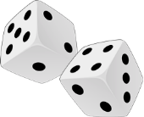  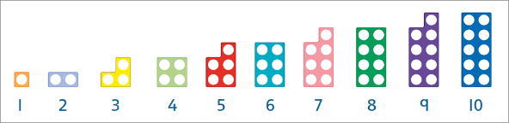   |  |  |  | 4 + 5 = 9  9 – 5 = 4 | Addition

Year 1 | NC Statement:  Pupils should be taught to:  - read, write and interpret mathematical statements involving addition (+), subtraction  - (–) and equals (=) signs  - represent and use number bonds and related subtraction facts within 20  - add and subtract one-digit and two-digit numbers to 20, including zero  - solve one-step problems that involve addition and subtraction, using concrete objects and pictorial representations, and missing number problems such as ? - 7 = – 9.  - solve one-step problems involving multiplication and division, by calculating the answer using concrete objects, pictorial representations and arrays with the support of the teacher |  |  | Addition
Concrete |  | Pictorial | Abstract - Written symbolic | Addition
  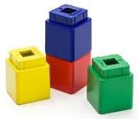  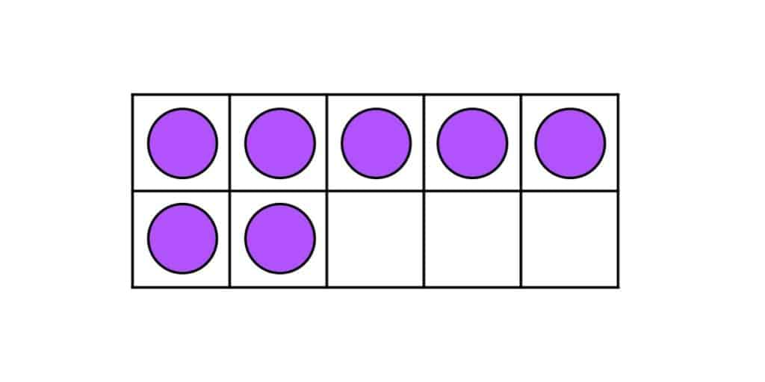 |  | 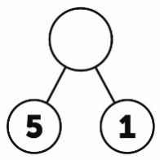 | 5 + 1 = 6  6 = 1 + 5  ? – 6 = 7 | Addition

Year 2 | NC Statement:  Add and subtract numbers using concrete objects, pictorial representations, and mentally, including:  - a two-digit number and ones  - a two-digit number and tens  - two, two-digit numbers |  |  | Addition
2LS15 Step 3: Expanded written method with no regrouping (2-digit numbers) |  |  |  | Addition
Concrete |  | Pictorial | Abstract - Written symbolic | Addition
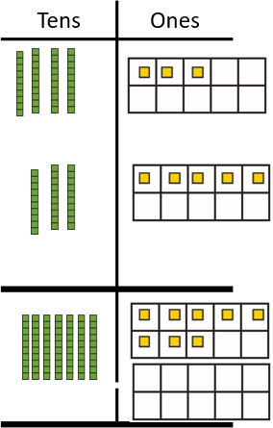 |  | 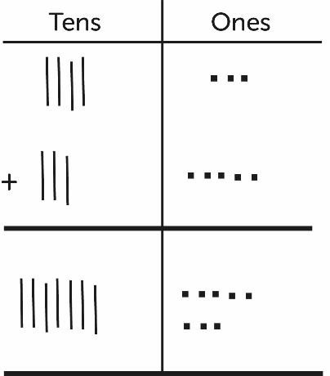 | 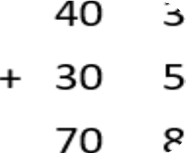  43 + 35 = 78 | Addition
Abstract - Speaking frame  The sum of … ones and … ones is ... ones. The sum of … tens and … tens is … tens.  So, … + … is equal to … tens and … ones, which is … |  |  | Notes:  Using embedded tens frame supports pupils to organise ones in preparation for regrouping. | Addition

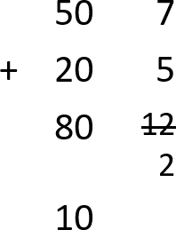
Year 2 | NC Statement:  Add and subtract numbers using concrete objects, pictorial representations, and mentally, including:  - a two-digit number and ones  - a two-digit number and tens  - two, two-digit numbers |  |  | Addition
2LS15 Step 4: Expanded written method with regrouping of ones (2-digit numbers) |  |  |  | Addition
Concrete  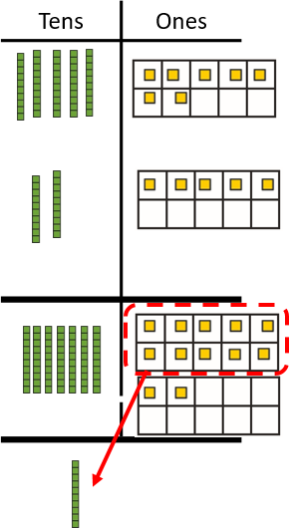 |  | Pictorial  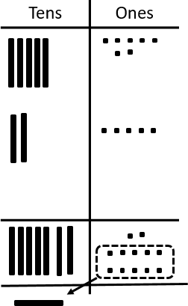 | Abstract - Written symbolic | Addition
 |  |  | +  +  +  57 + 25 = 92 | Addition
Abstract - Speaking frame  The sum of … ones and … ones is ... ones. This is regrouped into … ten and … ones.  The sum of … tens and … tens is …tens.  So, … + … is equal to … tens and … ones, which is … |  |  | Notes:  Pupils should be encouraged to estimate first and check their answer using a mental method.  Using embedded tens frame supports pupils to rapidly see the regroup and to keep their jottings organised. | Addition

Year 3 | NC Statement:  Add and subtract numbers with up to three digits, using formal written methods of columnar addition and subtraction |  |  | Addition
3LS8 Step 2: Formal written addition with no regrouping (up to three-digit numbers) |  |  |  | Addition
Concrete |  | Pictorial | Abstract - Written symbolic | Addition
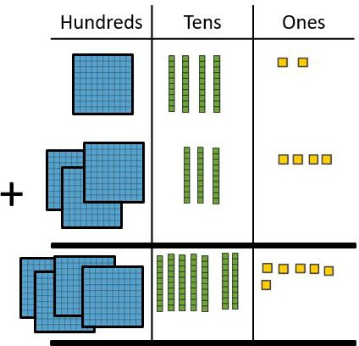 |  | 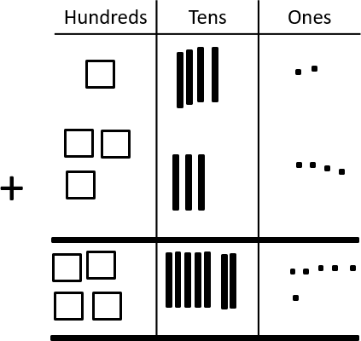 | 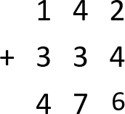  142 + 334 = 476 | Addition
Abstract - Speaking frame  The sum of … ones and … ones is ... ones. The sum of … tens and … tens is …tens.  The sum of … hundreds and … hundreds is … hundreds. So, … + … is equal to … hundreds, … tens and … ones, which is … . |  |  | Notes:  3LS8 Step 2 revisits the formal written method, first encountered in Year 2, with no regrouping but introduces hundreds.  Pupils should be encouraged to estimate first and check their answer using a mental method. | Addition

Year 3 | NC Statement:  Add and subtract numbers with up to three digits, using formal written methods of columnar addition and subtraction |  |  | Addition
3LS8 Step 3: Formal written addition with regrouping of ones (up to three-digit numbers) |  |  |  | Addition
Concrete |  | Pictorial | Abstract - Written symbolic | Addition
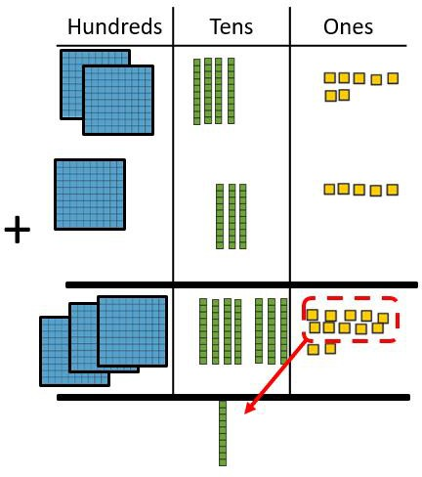 |  | 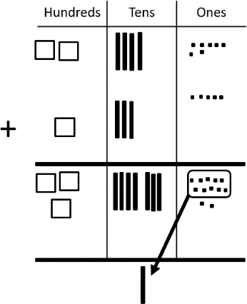 | 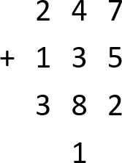  247 + 135 = 382 | Addition
Abstract - Speaking frame  The sum of … ones and … ones is ... ones. The sum of … tens and … tens is …tens.  The sum of … hundreds and … hundreds is … hundreds. So, … + … is equal to … hundreds, … tens and … ones, which is … . |  |  | Notes:  The focus is on regrouping of ones.  Pupils should be encouraged to estimate first and check their answer using a mental method. | Addition

Addition
Year 3 | NC Statement:  Add and subtract numbers with up to three digits, using formal written methods of columnar addition and subtraction
3LS8 Step 4: Formal written addition with regrouping tens only (up to three-digit numbers)
Concrete  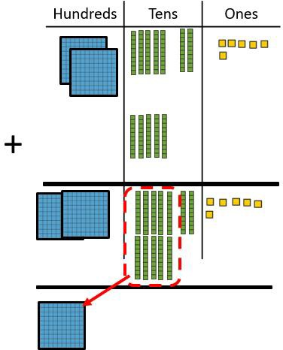 |  | Pictorial  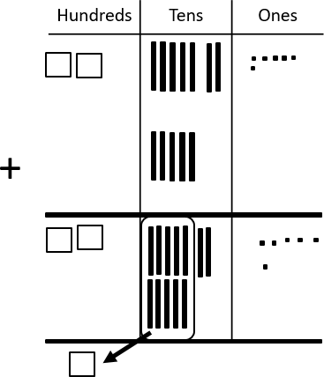 |  | Abstract - Written symbolic
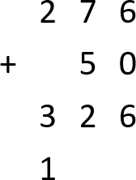

276 + 50 = 326
Abstract - Speaking frame  The sum of … ones and … ones is ... ones. This is regrouped into … tens and … ones. The sum of … tens and … tens is …tens.  The sum of … hundreds and … hundreds is … hundreds.  So, … + … is equal to … hundreds, … tens and … ones, which is …. |  |  | Notes:  The focus is on regrouping of tens.  Pupils should be encouraged to estimate first and check their answer using a mental method.

Addition
Year 3 | NC Statement:  Add and subtract numbers with up to three digits, using formal written methods of columnar addition and subtraction
3LS8 Step 4: Formal written addition with regrouping tens and ones (up to three-digit numbers)
Concrete |  | Pictorial | Abstract - Written symbolic
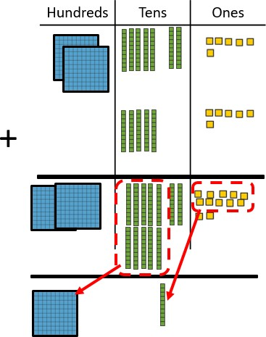 |  | 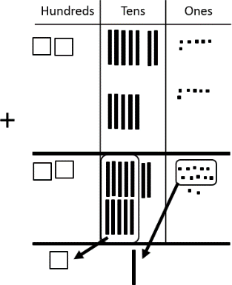 | 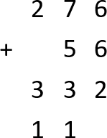  276 + 56 = 332
Abstract - Speaking frame  The sum of … ones and … ones is ... ones. This is regrouped into … tens and … ones. The sum of … tens and … tens is …tens.  This is regrouped into … hundreds and … tens.  The sum of … hundreds and … hundreds is … hundreds.  So, … + … is equal to … hundreds, … tens and … ones, which is … |  |  | Notes:  Pupils should be encouraged to estimate first and check their answer using a mental method.  Once pupils have fully understood and rehearsed regrouping within formal column addition of 3-digit numbers, this learning continues to be rehearsed and applied throughout Years 4, 5 and 6, including to 4-digit numbers, larger numbers, decimal numbers, money and measures.

Subtraction
Year 2 | NC Statement:  add and subtract numbers using concrete objects, pictorial representations, and mentally, including:  - a two-digit number and ones  - a two-digit number and tens  - two, two-digit numbers.
2LS17 Step 4: Expanded written subtraction, a 2-digit number from a 2-digit number with no regrouping
Concrete |  | Pictorial | Abstract - Written symbolic
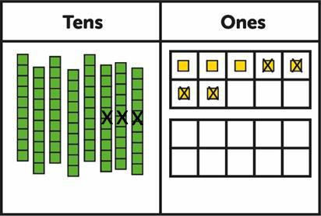 |  | 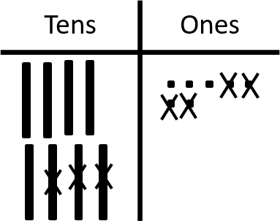 | 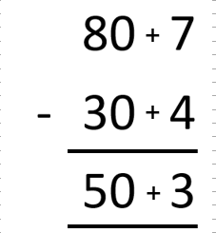  87 – 34 = 53
Abstract - Speaking frame  … ones take away … ones leaves … ones.  … tens take away … tens leaves … tens.  So, … - … is equal to… tens and … ones, which is … . |  |  | Notes:  Pupils should be encouraged to estimate first and check their answer using a mental method.

Year 2 | NC Statement:  add and subtract numbers using concrete objects, pictorial representations, and mentally, including:  - a two-digit number and ones  - a two-digit number and tens  - two, two-digit numbers. |  |  | Subtraction
2LS17 Step 5: Expanded written subtraction, a 2-digit number from a 2-digit number with regrouping |  |  |  | Subtraction
Concrete |  | Pictorial | Abstract - Written symbolic | Subtraction
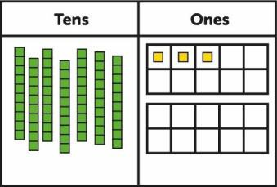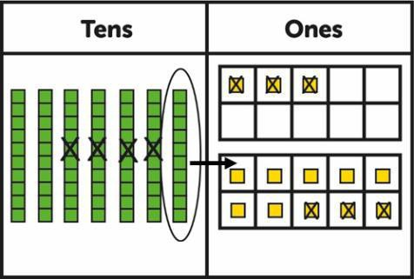 |  | 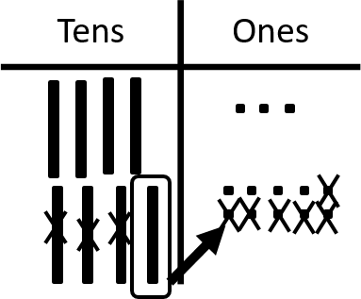 | 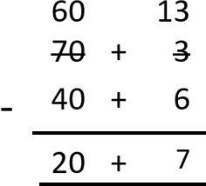  73 – 46 = 27 | Subtraction
Abstract - Speaking frame  I can see that there aren’t enough ones for me to take away … ones without regrouping.  Regroup one ten into ten ones. There are now … tens and … ones.  … ones take away … ones leaves … ones.  … tens take away … tens leaves … tens.  So, … – … is equal to… tens and … ones, which is … . |  |  | Notes:  Using embedded tens frame supports pupils to regroup accurately and to keep their jottings organised.  Speaking frame note: “I can see that there aren’t enough ones for me to take away 6 ones without regrouping. Regroup one ten into ten ones. There are now 6 tens and 13 ones.” | Subtraction

Subtraction
Year 3 | NC Statement:  Add and subtract numbers with up to three digits, using formal written methods of columnar addition and subtraction
3LS9 Step 1: Formal written subtraction with no regrouping (up to 3-digit numbers)
Concrete |  | Pictorial | Abstract - Written symbolic
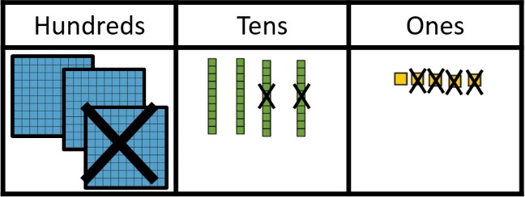 |  | 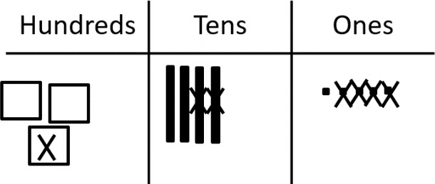 | 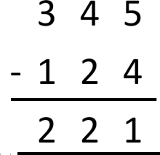  345 – 124 = 221
Abstract - Speaking frame |  |  | Notes:
 |  |  | Pupils should be encouraged to estimate first
… ones take away … ones leaves … ones. |  |  | and check their answer using a mental method.
… tens take away … tens leaves … tens.
… hundreds take away … hundreds leaves … hundreds.
So, … – … is equal to … hundreds, … tens and … ones, which is …

Year 3 | NC Statement:  Add and subtract numbers with up to three digits, using formal written methods of columnar addition and subtraction |  |  | Subtraction
3LS9 Step 2: Formal written subtraction – regrouping tens into ones only (up to 3-digit numbers) |  |  |  | Subtraction
Concrete |  | Pictorial | Abstract - Written symbolic | Subtraction
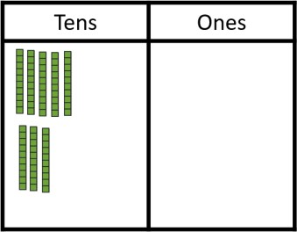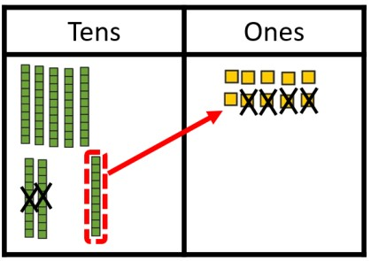 |  | 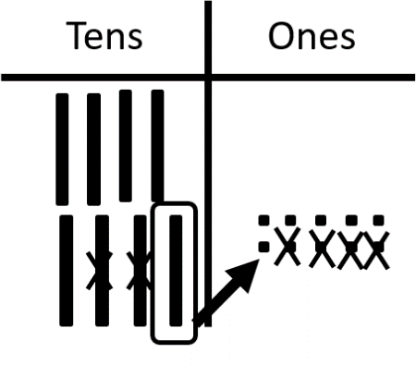 | 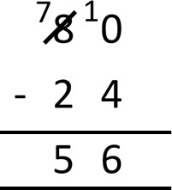  80 – 24 = 56 | Subtraction
Abstract - Speaking frame  I can see that there aren’t enough ones for me to take away  … ones without regrouping. Regroup one ten into ten ones. There are now … tens and … ones.  … ones take away … ones leaves … ones.  … tens take away … tens leaves … tens.  So, … – … is equal to… tens and … ones, which is … . |  |  | Notes:  It is important that pupils understand that 80 has been regrouped into 70 and 10. If pupils struggle with the compact notation refer to 2LS17 Step 5 for the expanded method.  Speaking frame note:  “I can see that there aren’t enough ones for me to take away 4 ones without regrouping. Regroup one ten into ten ones. There are now ten ones and zero ones. 10 ones take away 4 ones leaves six ones. 7 tens take away 2 tens leaves 5 tens. So, 80 – 24 is equal to 5 tens and 6 ones, which is 56.” | Subtraction

Year 3 | NC Statement:  Add and subtract numbers with up to three digits, using formal written methods of columnar addition and subtraction |  |  | Subtraction
3LS9 Step 3: Formal written subtraction – regrouping hundreds into tens only (up to 3-digit numbers) |  |  |  | Subtraction
Concrete |  | Pictorial | Abstract - Written symbolic | Subtraction
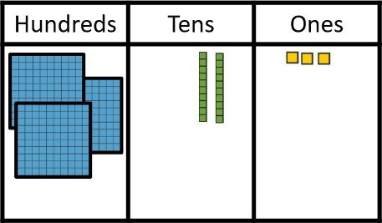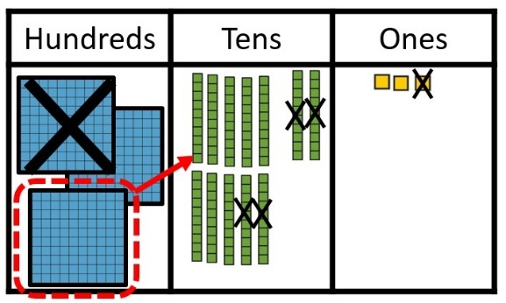 |  | 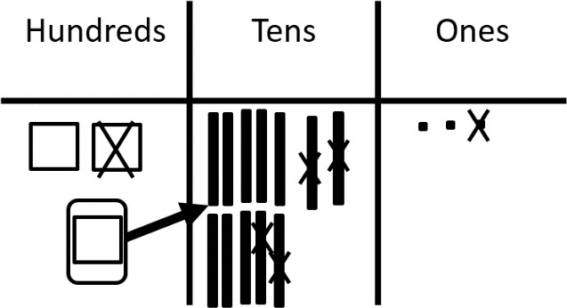 | 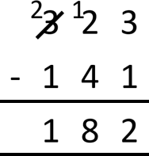  323 – 141 = 182 | Subtraction
Abstract - Speaking frame  … ones take away … ones leaves … ones.  I can see that there aren’t enough tens for me to take away … tens without regrouping.  Regroup one hundred into ten hundreds. There are now … hundreds and … tens.  … tens take away … tens leaves … tens.  … hundreds take away … hundreds leaves … hundreds  So, … – … is equal to … hundreds, … tens and … ones, which is …. |  |  | Notes:  It is important that pupils start to identify where regrouping is necessary.  Ensure that pupils are confident that the minuend may have been regrouped but it is still of equal value prior to subtraction. | Subtraction

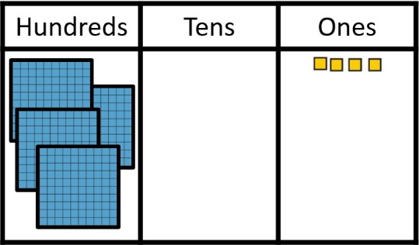
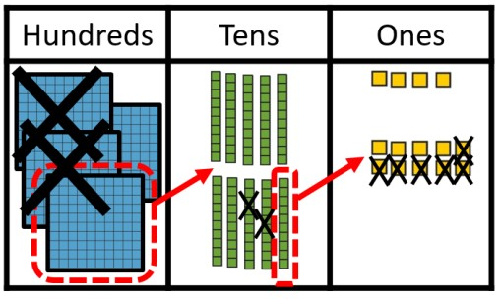
Subtraction
Year 3 | NC Statement:  Add and subtract numbers with up to three digits, using formal written methods of columnar addition and subtraction
3LS9 Step 4: Formal written subtraction - regrouping hundreds and tens (up to 3-digit numbers)
Concrete |  | Pictorial  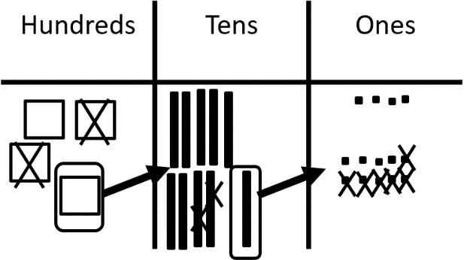 |  | Abstract - Written symbolic  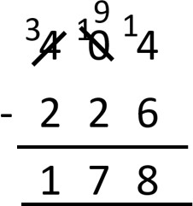  404 – 226 = 178
Abstract - Speaking frame  I will need to regroup…  - one hundred into ten tens. I now have … hundreds and … tens.  - one ten into ten ones. I now have … tens and … ones. |  |  | Notes:  Speaking frame hint: This is not a complete speaking frame. It is structured to support pupils with the language of regroup only.  Once pupils have fully understood and rehearsed regrouping within formal subtraction, this learning continues to be rehearsed and applied throughout Years 4, 5 and 6, including to multi-digit, decimal numbers, money and measures.

Year 3 | NC Statement:  Write and calculate mathematical statements for multiplication and division using the multiplication tables that they know, including for two-digit numbers times one-digit numbers, using mental and progressing to formal written methods |  |  | Multiplication
3LS26 Step 3: Introducing short multiplication with no regrouping |  |  |  | Multiplication
Concrete |  | Pictorial - Jottings | Abstract - Written symbolic | Multiplication
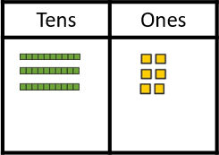 |  | 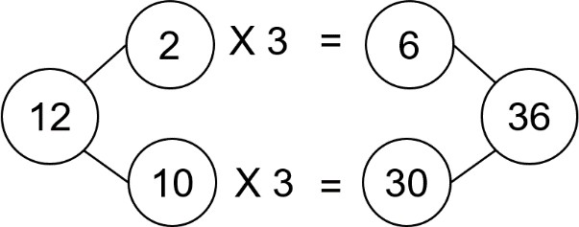 | 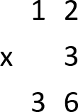  12 x 3 = 36 | Multiplication
Abstract - Speaking frame  … groups of … ones is … ones.  … groups of … tens is … tens.  … tens added to … ones is … . The product of … and … is … . |  |  | Notes:  Pupils have already met the distributive law (3LS18) and rehearsed multiplying by ten (3LS25).  The focus of this step is support pupils in making the connection between informal distributive approach and the formal layout.  Speaking frame note:  “3 groups of 2 ones is 6 ones. 3 groups of 1  ten is 3 tens. 3 tens added 6 ones is 36.  The product of 12 and 3 is 36.” | Multiplication

Year 3 | NC Statement:  Write and calculate mathematical statements for multiplication and division using the multiplication tables that they know, including for two-digit numbers times one-digit numbers, using mental and progressing to formal written methods |  |  | Multiplication
3LS26 Step 4: Short multiplication with regrouping of ones into tens only |  |  |  | Multiplication
Concrete |  | Pictorial - Jottings | Abstract - Written symbolic | Multiplication
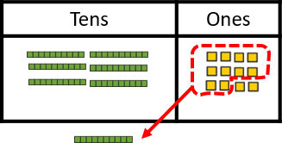 |  | 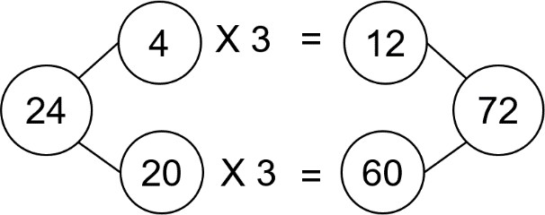 | 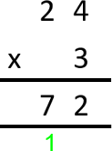  24 x 3 = 72 | Multiplication
Abstract - Speaking frame  … groups of … ones is … ones.  I can regroup the … ones into … ten(s) and … one(s).  … groups of … tens is … tens.  … ten(s) added to … is … .  The product of … and … is … . |  |  | Notes:  Pupils have already met the distributive law (3LS18) and rehearsed multiplying by ten (3LS25).  The focus of this step is to support pupils in making the connection between informal distributive approach and the formal layout. Speaking frame note:  “3 groups of 4 ones is 12 ones. I can regroup the 12 ones into 1 ten and 2 ones. 3 groups  of 2 tens is 6 tens. 1 ten added to 6 tens is 7  tens. The product of 24 x 3 is 72.”  Pupils should be encouraged to consider whether italicised language in the speaking frame is required in the calculation. | Multiplication

Year 3 | NC Statement:  Write and calculate mathematical statements for multiplication and division using the multiplication tables that they know, including for two-digit numbers times one-digit numbers, using mental and progressing to formal written methods |  |  | Multiplication
3LS26 Step 5: Short multiplication with regrouping of tens and ones |  |  |  | Multiplication
Concrete |  | Pictorial - Jottings | Abstract - Written symbolic | Multiplication
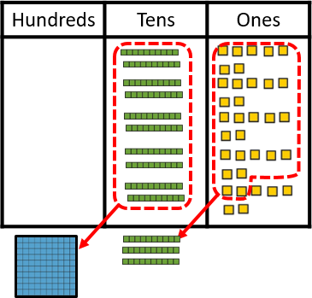 |  | 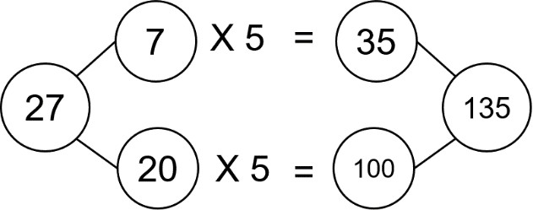 | 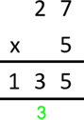  27 x 5 = 135 | Multiplication
Abstract - Speaking frame  … groups of … ones is … ones.  I can regroup the … ones into … ten(s) and … one(s).  … groups of … tens is … tens.  … ten(s) added to … ten(s) is ..  I can regroup the … tens into … hundred(s) and … ten(s) The product of … and … is … . |  |  | Notes:  At this stage, the pictorial representation is being used as a checking point to ensure pupils answer accurately. This allows focused attention on understanding the abstract recording.  Speaking frame note:  “5 groups of 7 ones is 35 ones. I can regroup the 35 ones into 3 tens and 5 ones. 5 groups  of 2 tens is 10 tens. 3 tens added to 10 tens is 13 tens. I can regroup the 13 tens into 1 hundred and 3 tens. The product of 27 x 5 is 135.” | Multiplication

Year 4 | NC Statement:  Multiply 2-digit and 3-digit numbers by a one-digit number using formal written layout (short multiplication) |  |  | Multiplication
4LS24 Step 5: Formal written multiplication with regrouping which generates a new column |  |  |  | Multiplication
Concrete |  | Pictorial - Jottings | Abstract - Written symbolic | Multiplication
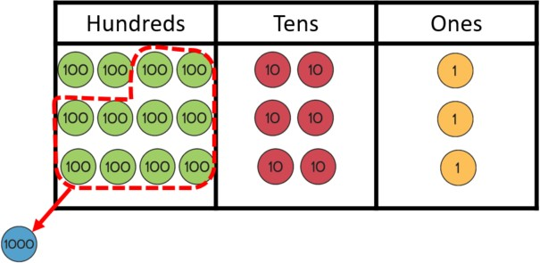 |  | 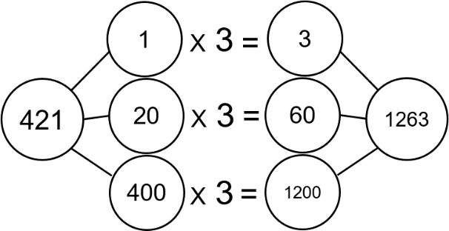 | 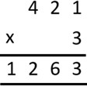  421 x 3 = 1263 | Multiplication
Abstract - Speaking frame  … groups of … ones is … ones. (Do I need to regroup?)  … groups of … tens is … tens. (Do I need to regroup?)  … groups of … hundreds is … hundreds. (Do I need to regroup?) (… hundreds can be regrouped to … thousands and … hundreds) The product of … and … is … . |  |  | Notes:  At this stage, the pictorial representation is being used as a checking point to ensure that pupils answer accurately. This allows focused attention on understanding the abstract recording.  Pupils should be encouraged to consider whether the italicised language in the speaking frame is required in the calculation. | Multiplication

Multiplication
Year 5 | NC Statement:  Multiply numbers up to 4 digits by a one- or two-digit number using a formal written method, including long multiplication for two-digit numbers
5LS11 Step 2: Expanded vertical multiplication 2-digit by 2-digit
Concrete  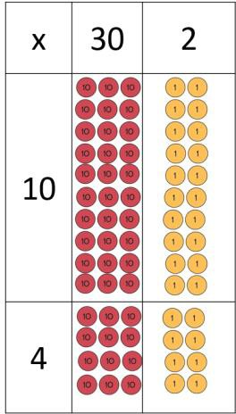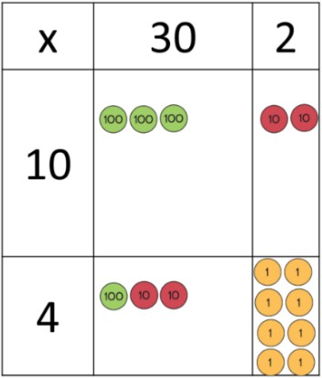 |  | Pictorial - Jottings  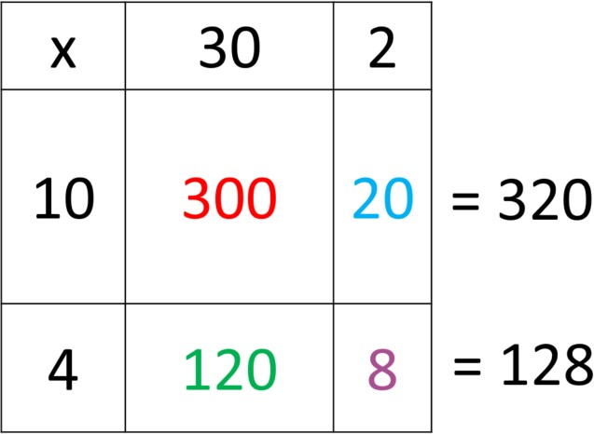 |  | Abstract - Written symbolic  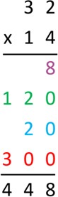  32 x 14 = 448
Abstract - Speaking frame  First, I need to consider the ones in the multiplier.  … groups of … ones is ones.  … groups of … tens is tens. (Do I need to regroup?)  Then, tens in the multiplier.  … groups of … ones is ones. (Do I need to regroup?)  … groups of … tens is tens. (Do I need to regroup?)  The total of all the partial products is … . The product of … and … is … . |  |  | Notes:  This is a transitional method towards long multiplication. Using the grid supports pupils in their thinking about multiplying by powers of ten and place value. Secure understanding of both of these concepts allow pupils to move to long multiplication more successfully.  Speaking frame hint: linking to what we know and correct place value. For example, 10 groups of 3 tens is 30 tens. This can be regrouped to 3 hundreds.

Multiplication
Year 5 | NC Statement:  Multiply numbers up to 4 digits by a one- or two-digit number using a formal written method, including long multiplication for two-digit numbers
5LS11 Step 3: Long multiplication 2-digit by 2-digit with simple regrouping
Concrete  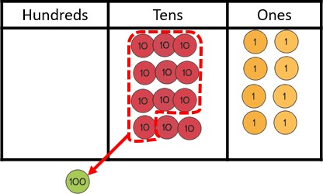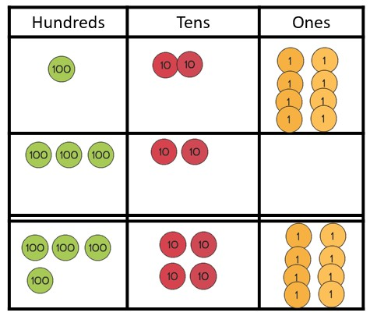 |  | Pictorial - Jottings |  | Abstract - Written symbolic  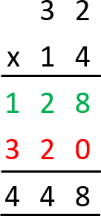  32 x 14 = 448
Abstract - Speaking frame  First, I need to consider the ones in the multiplier.  … groups of … ones is ones. (Do I need to regroup?)  … groups of … tens is tens. (Do I need to regroup?) Then, considering tens in the multiplier.  … groups of … ones is ones. (Do I need to regroup?)  … groups of … tens is tens. (Do I need to regroup?) The total of all the partial products is … .  The product of … and … is … . |  |  | Notes:  Speaking frame hint: linking to what we know and correct place value.  For example, 10 groups of 3 tens is 30 tens (linking to known fact 10 x 3). This can be regrouped to 3 hundreds.

Year 5 | NC Statement:  Multiply numbers up to 4 digits by a one- or two-digit number using a formal written method, including long multiplication for two-digit numbers |  |  |  | Multiplication
5LS11 Step 3: Long multiplication 2-digit by 2-digit, focusing on regroup in first partial product |  |  |  |  | Multiplication
Concrete |  | Pictorial |  | Abstract - Written symbolic | Multiplication
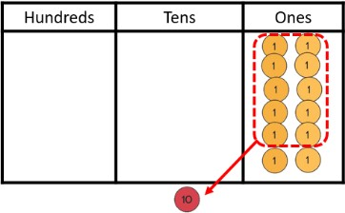 |  | 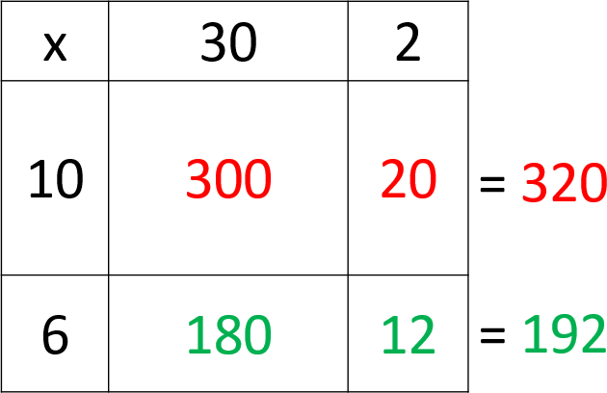 |  | 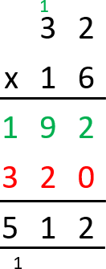  32 x 16 = 512 | Multiplication
Abstract - Speaking frame  First, I need to consider the ones in the multiplier.  … groups of … ones is … ones. (Do I need to regroup?)  … groups of … tens is … tens. (Any regroups to add? Do I need to regroup?)  Then, considering tens in the multiplier.  … groups of … ones is … ones. (Do I need to regroup?)  … groups of … tens is … tens. (Do I need to regroup?)  The total of all the partial products is … . The product of … and … is … . |  |  | Notes:  Speaking frame hint: linking to what we know and correct place value.  For example, 6 groups of 3 tens is 18 tens (linking to known fact 6 x 3 = 18). This can be regrouped to 1 hundred and 8 tens. |  | Multiplication

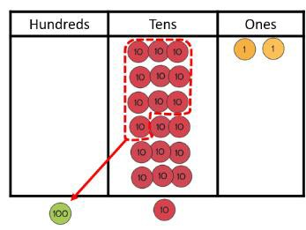
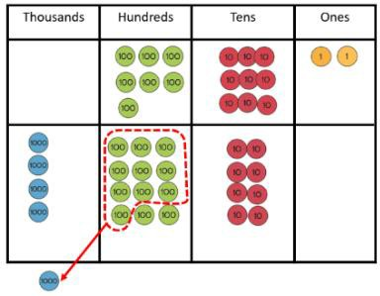
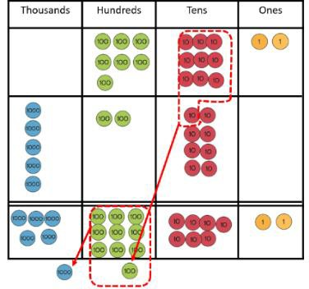
Multiplication

Year 5 | NC Statement:  Multiply numbers up to 4 digits by a one- or two-digit number using a formal written method, including long multiplication for two-digit numbers
5LS11 Step 3: Long multiplication 2-digit by 2-digit regrouping in first and second stage
Concrete |  | Pictorial - Jottings  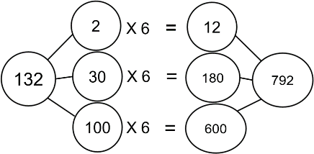  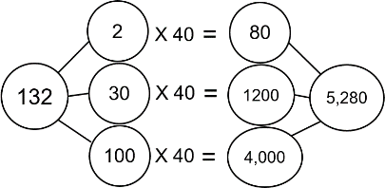 |  | Abstract - Written symbolic  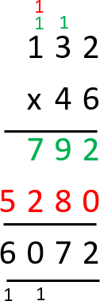  132 x 46 = 6,072
Abstract - Speaking frame  First, I need to consider the ones in the multiplier.  … groups of … ones is … ones. (Do I need to regroup?)  … groups of … tens is … tens. (Any regroups to add? Do I need to regroup?)  Then, considering tens in the multiplier.  … groups of … ones is … ones. (Do I need to regroup?)  … groups of … tens is … tens. (Any regroups to add? Do I need to regroup?)  The total of all the partial products is … . The product of … and … is … . |  |  | Notes:  Speaking frame hint: linking to what we know and correct place value.  For example, 6 groups of 3 tens is 18 tens (linking to known fact 6 x 3 = 18). This can be regrouped to 1 hundred and 8 tens.

Multiplication

Year 6 | NC Statement:  Multiply numbers up to 4 digits by a one- or two-digit number using a formal written method, including long multiplication for two-digit numbers
6LS12 Step 5: Formal written multiplication involving numbers with up to 2 decimal places multiplied by a 1-digit number
Concrete |  | Pictorial - Jottings | Abstract - Written symbolic
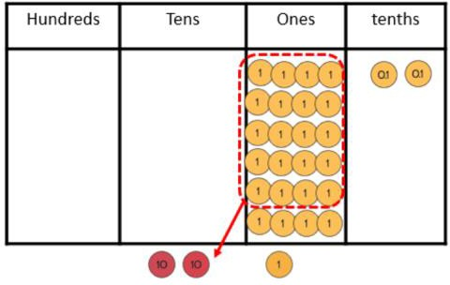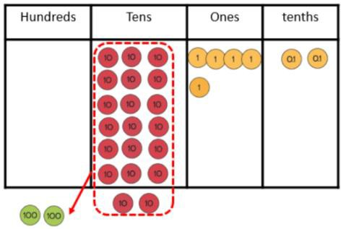 |  | Jottings: multiples of tricky multipliers  6  12  18  24  30  36  42  48  54  60  66  72 | 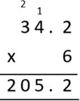  34.2 x 6 = 205.2
Abstract - Speaking frame  … groups of … tenths is … tenths. (Do I need to regroup?)  … groups of … ones is … ones. (Any regroups to add? Do I need to regroup?)  … groups of … tens is … tens. (Any regroups to add? Do I need to regroup?)  The product of … and … is … . |  |  | Notes:  Speaking frame hint: linking to what we know and correct place value.  For example, 6 groups of 3 tens is 18 tens (linking to known fact 6 x 3 = 18). This can be regrouped to 1 hundred and 8 tens.

Year 3 | NC Statement:  Write and calculate mathematical statements for multiplication and division using the multiplication tables that they know, including for two-digit numbers times one-digit numbers, using mental and progressing to formal written methods |  |  | Division
3LS30 Step 2: Introducing the long division method (sharing ones) |  |  |  | Division
Concrete |  | Pictorial | Abstract - Written symbolic | Division
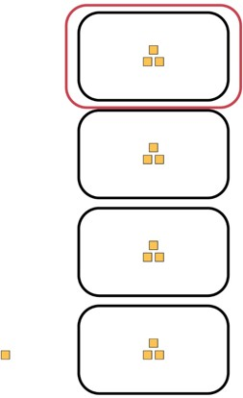 |  | 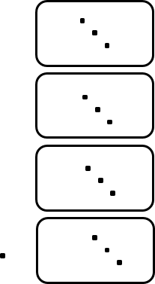 | 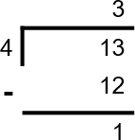  13 ÷ 4 = 3 r 1 | Division
Abstract - Speaking frame  I am sharing … ones into … equal groups. There are … ones in each group.  I have … one(s) remaining.  The quotient is … with … remainders. |  |  | Notes:  Pupils are introduced to the long division method for the first time in this sequence. Short division will not be introduced until pupils have understood all of the stages in this expanded form. In the calculation 96 ÷ 4, for example, pupils often struggle to understand that 1 ten will be regrouped after 8 tens have been used in the 4 groups. This is hidden in short division but recorded in long division. | Division

Year 3 | NC Statement:  Write and calculate mathematical statements for multiplication and division using the multiplication tables that they know, including for two-digit numbers times one-digit numbers, using mental and progressing to formal written methods |  |  | Division
3LS30 Step 3: Long division of tens and ones with no regrouping (sharing structure) |  |  |  | Division
Concrete |  | Pictorial | Abstract - Written symbolic | Division
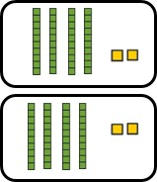 |  | 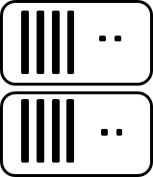 | 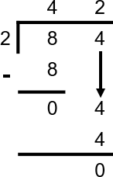  84 ÷ 2 = 42 | Division
Abstract - Speaking frame  First, I am sharing … tens into … equal groups. There are … tens in each group.  I have … ten(s) remaining.  Then, I am sharing … ones into … equal groups. There are … ones in each group.  I have … one(s) remaining.  The quotient is … with … remainders. |  |  | Notes:  This stage is to support pupils’ understanding of the abstract notation. They learn to record how many tens are in each group, if there are any tens remaining and what the arrow means.  Speaking frame note: “First, I am sharing 8 tens into 2 equal groups. There are 4 tens in each group. I have zero tens remaining.  Then, I am sharing 4 ones into 2 equal groups. There are 2 ones in each group. I have zero ones remaining. The quotient is 42  with no remainders.” | Division

Year 3 | NC Statement:  Write and calculate mathematical statements for multiplication and division using the multiplication tables that they know, including for two-digit numbers times one-digit numbers, using mental and progressing to formal written methods |  |  | Division
3LS30 Step 4: Long division of tens and ones with regrouping (sharing structure) |  |  |  | Division
Concrete |  | Pictorial | Abstract - Written symbolic | Division
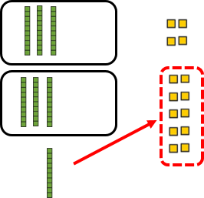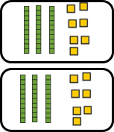 |  | 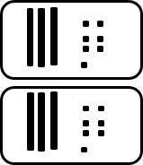 | 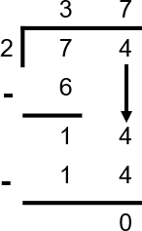  74 ÷ 2 = 37 | Division
Abstract - Speaking frame  First, I am sharing … tens into … equal groups. There are … tens in each group.  I have … ten(s) remaining.  I need to regroup the remaining … ten(s) into … ones. I now have … ones in total.  Then, I am sharing … ones into … equal groups. There are … ones in each group.  I have … one(s) remaining.  The quotient is … with … remainders. |  |  | Notes:  This is a crucial stage as it demonstrates the regrouping of the remaining tens for ones and how this is recorded abstractly.  Speaking frame note: “… I have 1 ten remaining. I need to regroup the remaining 1 ten into 10 ones. I now have 14 ones in total...” | Division

Year 4 | NC Statement:  Pupils practise to become fluent in the formal written method of short multiplication and short division with exact answers (non-statutory guidance) |  |  | Division
4LS25 Step 2: Long division with regrouping hundreds into tens (sharing structure) |  |  |  | Division
Concrete |  | Pictorial | Abstract - Written symbolic | Division
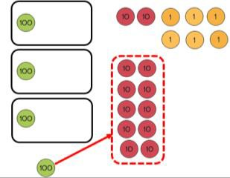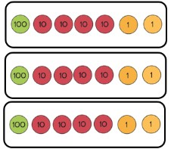 |  | 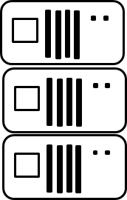 | 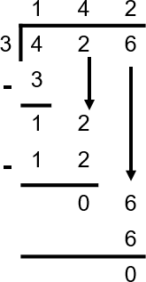  426 ÷ 3 = 142 | Division
Abstract - Speaking frame  First, I am sharing … hundreds into … equal groups. There are … hundreds in each group.  I have … hundred(s) remaining.  I need to regroup the remaining … hundreds into …tens. I now have … tens in total.  Next, I am sharing … tens into .. equal groups. |  |  | Notes:  Pupils revisit long division with no regrouping gin 4LS25 step 1. This is to ensure that they understand the abstract recording of long division.  Speaking frame note: This stage is an extension to the previous speaking frame – focusing on the hundreds regroup. | Division

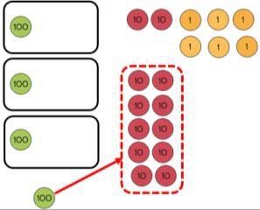
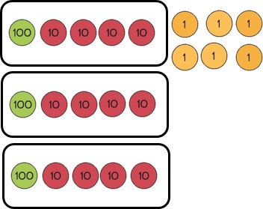
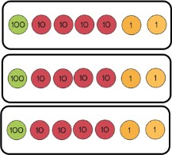
Year 4 | NC Statement:  Pupils practise to become fluent in the formal written method of short multiplication and short division with exact answers (non-statutory guidance) |  |  | Division
4LS25 Step 4: Introducing formal short division (sharing structure) |  |  |  | Division
Concrete |  | Pictorial | Abstract - Written symbolic | Division
 |  |  | 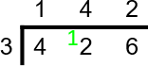  426 ÷ 3 = 142 | Division
Abstract - Speaking frame  First, I am sharing … hundreds into … equal groups. There are … hundreds in each group.  I have … hundred(s) remaining.  I need to regroup the remaining … hundreds into … tens. I now have … tens in total.  Next, I am sharing … tens into .. equal groups. |  |  | Notes:  In this stage, pupils learn that the thinking processes for long and short division are the same – it is only the abstract written that is different. It is important that pupils are able to link this to the long division format and can explain the compaction.  Speaking frame note: This stage is an extension to the previous speaking frame – focusing on the hundreds regroup. | Division

Year 5 | NC Statement:  Divide numbers up to 4 digits by a one-digit number using the formal written method of short division and interpret remainders appropriately for the context |  |  | Division
5LS12 Step 2: Introducing formal short division regroup from tens to ones (grouping structure) |  |  |  | Division
Concrete |  | Pictorial - Jottings | Abstract - Written symbolic | Division
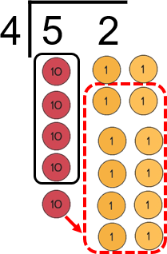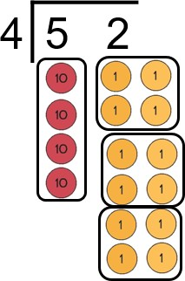 |  | 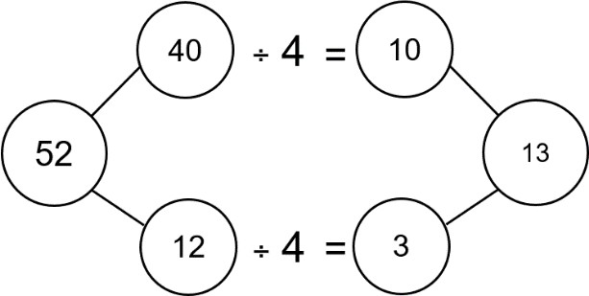 | 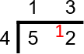  52 ÷ 4 = 13 | Division
Abstract - Speaking frame  I want to know how many groups of … are in … .  How many groups of … tens are in … tens without regrouping?  I can make … group(s) of … tens. There is/are … ten(s) remaining. I need to regroup the … tens into … ones.  I now have … ones.  How many groups of … ones are in … ones, without regrouping?  I can make … group(s) of … ones. There is/are … one(s) remaining. There are … groups of … in … with … remainders. |  |  | Notes:  Pupils are encouraged to progress to a grouping model of division. This is in preparation for 2-digit divisors and understanding fractions expressed as part of the quotient.  Pupils should explore with simple division calculations to ensure that they understand the shift in structure.  Speaking frame note: In this example, the speaking frame would be completed like this: “How many groups of 3 tens are in 4 tens, without regrouping?”  This is to ensure that accurate place value and magnitude is maintained. | Division

Division
Year 5 | NC Statement:  Divide numbers up to 4 digits by a one-digit number using the formal written method of short division and interpret remainders appropriately for the context
5LS12 Step 3: Short division for numbers up to 4-digits (grouping structure)
Concrete |  | Pictorial - Jottings |  | Abstract - Written symbolic
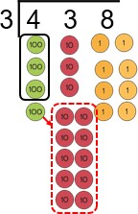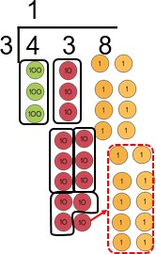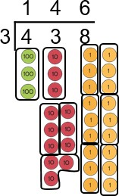 |  | 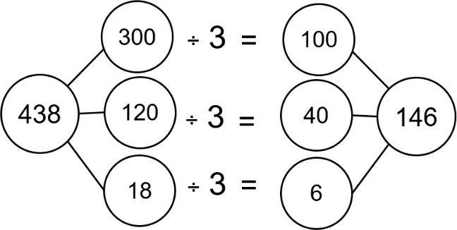 |  | 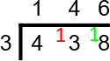  438 ÷ 3 = 146
Abstract - Speaking frame  I want to know how many groups of … are in … .  How many groups of … hundreds are in … hundreds, without regrouping?  I can make … group(s) of …hundreds. There is/are … hundred(s) remaining.  I need to regroup the … hundreds into …tens. |  |  | Notes:  Speaking frame note: This is an extension to the previous speaking frame.  In this example, the speaking frame would be completed like this:  “How many groups of 3 hundreds are in 4 hundreds, without regrouping?”  This is to ensure that accurate place value and magnitude is maintained.

Year 5 | NC Statement:  Divide numbers up to 4 digits by a one-digit number using the formal written method of short division and interpret remainders appropriately for the context |  |  |  | Division
5LS12 Step 4: Short division (grouping structure) - expressing quotients with fractions |  |  |  |  | Division
Concrete |  | Pictorial |  | Abstract - Written symbolic | Division
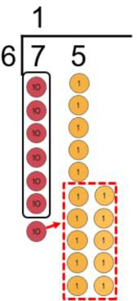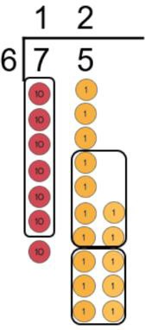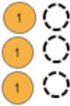 |  | 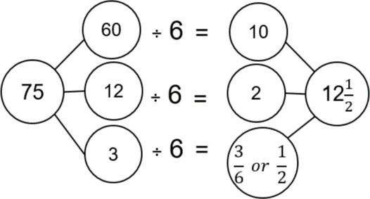 |  | 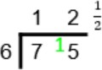  75 ÷ 6 = 12¹  2 | Division
Abstract - Speaking frame  I have a remainder of … .  This is … (remainder) out of … (divisor) which I need for another group. This can be written as a fraction .  This can be simplified to . |  |  | Notes:  Speaking frame note: This is an extension to the previous speaking frame (5LS12 Step 2). In this example the speaking frame would be completed like this:  “I have a remainder of 3.  This is 3 out of 6 which I need for another group.  This can be written as a fraction ³ .  6  This can be simplified to ¹.”  2 |  | Division

Division
Year 5 | NC Statement:  Divide numbers up to 4 digits by a one-digit number using the formal written method of short division and interpret remainders appropriately for the context
5LS12 Step 5: Short division (grouping structure) - expressing quotients with decimals
Concrete |  | Pictorial - Jottings |  | Abstract - Written symbolic
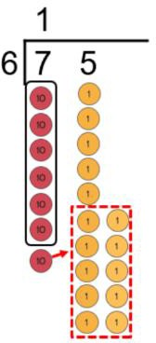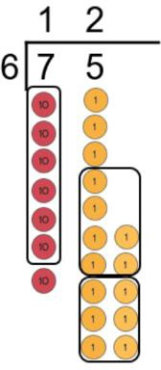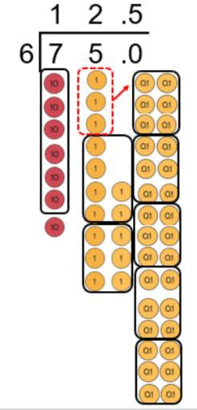 |  | Jottings: multiples of the divisor  6  12  18  24  30  36  42  48  54  60 |  | 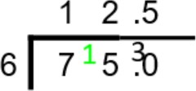  75 ÷ 6 = 12.5
Abstract - Speaking frame  I have a remainder of … .  I need to regroup the … ones into … tenths.  How many groups of … tenths are in … tenths, without regrouping? I can make … group(s) of … tenths.  There are … groups of … in … . |  |  | Notes:  Speaking frame note: This is an extension to the previous speaking frame (5LS12 Step 2). In this example, the speaking frame would be completed like this:  “I have a remainder of 3.  I need to regroup the 3 ones into 30 tenths. How many groups of 6 tenths are in 30 tenths, without regrouping?  I can make 5 groups of 6 tenths.  There are 12.5 groups of 6 in 75.”

Year 6 | NC Statement:  Divide numbers up to 4 digits by a two-digit whole number using the formal written method of long division and interpret remainders as whole number remainders , fractions, or by rounding, as appropriate for the context |  |  |  | Division
6LS17 Step 2: Long division for numbers up to 4 digits |  |  |  |  | Division
Concrete |  | Pictorial - Jottings |  | Abstract - Written symbolic | Division
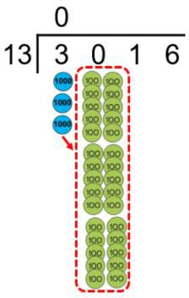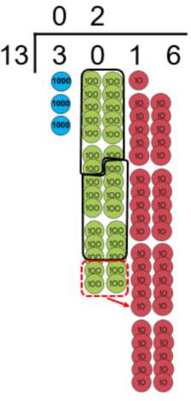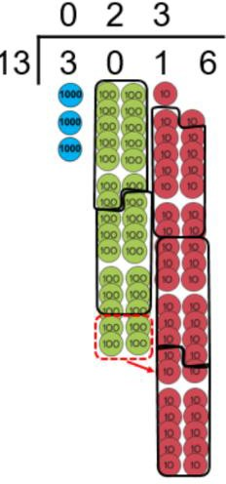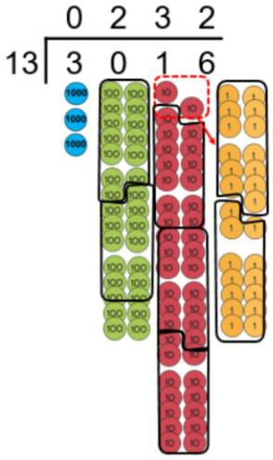 |  | Jottings: multiples of the divisor  13  26  39  52  65  78  91  104 |  | 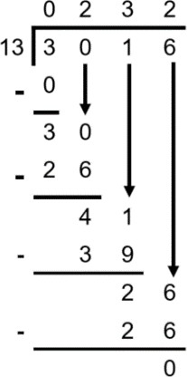  3016 ÷ 13 = 232 | Division
Abstract - Speaking frame  I want to know how many groups of … are in … .  How many groups of … thousand are in …thousand, without regrouping?  I can make … group(s) of …thousand. There is/are … thousand(s) remaining.  I need to regroup the … thousand(s) into …hundreds. |  |  | Notes:  The structure of long division was first introduced in 3LS30, then revisited and extended in both years 4 and  5. It was revised in Step 1 of this sequence.  Jottings are used to scaffold to derived related division facts.  Speaking frame note: This is an extension to the previous speaking frame (5LS12 Step 2). In this example, the speaking frame would be completed like this:  “How many groups of 13 thousands are in 3 thousand, without regrouping?” I can make zero groups of 13 thousand. There are 3 thousand remaining. I need to  regroup the 3 thousands into 30 hundreds.” |  | Division

These additional examples show only jottings, completed speaking frames and abstract recording. This complexity of calculation should only be introduced to pupils once they are confident in the conceptual pathway and can explain the abstract recording with reference to the concrete and pictorial models.
Additional Year 6 examples

Additional Year 6 examples  Year 6 | NC Statement:  Divide numbers up to 4 digits by a two-digit whole number using the formal written method of long division and interpret remainders as whole number remainders , fractions, or by rounding, as appropriate for the context
6LS17 Step 4: Long division for numbers up to 4 digits - expressing quotients with fractions
Abstract speaking frame |  | Pictorial - Jottings | Abstract - Written symbolic
I have a remainder of 9.  This is 9 out of the 15 which I need for another group.  This can be written as a fraction ⁹ .  15  This can be simplified to ³ .  5  There are 37³ in each of the 15 groups.  5 |  | Jottings: multiples of the | 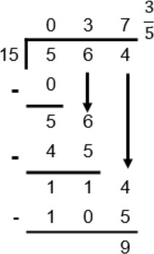  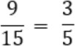  564 ÷ 15 = 37 ³  5
 |  | divisor
 |  | 15
 |  | 30
 |  | 45
 |  | 60
 |  | 75
 |  | 90
 |  | 105
 |  | 120
 |  | 135
 |  | 150

Additional Year 6 examples
Additional Year 6 examples  Year 6 | NC Statement:  Divide numbers up to 4 digits by a two-digit whole number using the formal written method of long division and interpret remainders as whole number remainders , fractions, or by rounding, as appropriate for the context
6LS17 Step 5: Long division for numbers up to 4 digits - expressing quotients with decimals
Abstract speaking frame |  | Pictorial - Jottings | Abstract - Written symbolic
 |  | Jottings: multiples of the divisor | 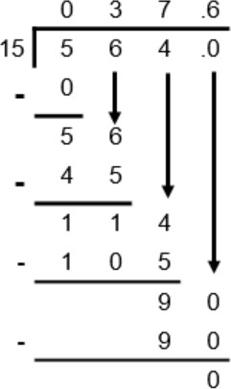  564 ÷ 15 = 37.6
 |  | 15
 |  | 30
I have a remainder of 9.  I need to regroup the 9 ones into |  | 45  60  75
90 tenths. |  | 90
How many groups of 15 tenths are |  | 105
in 90 tenths, without regrouping? |  | 120
I can make 6 groups of 15 tenths. |  | 135
There is nothing remaining. |  | 150
There are 37.6 groups of 15 in 564.

Additional Year 6 examples

Additional Year 6 examples  Year 6 | NC Statement:  Multiply multi-digit numbers of up to 4-digits by a two-digit whole number using the formal written method of long multiplication
6LS12 Step 3: Long multiplication; up to 4-digit by 2-digit
Abstract speaking frame |  | Pictorial - Jottings | Abstract - Written symbolic  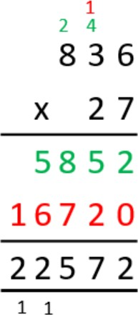  836 x 27 = 22,572
 |  | Jottings: multiples of tricky
 |  | multipliers
First, I need to consider the ones in the multiplier.
7 groups of 6 ones is 42 ones. |  | 7
I need to regroup into 4 tens and 2 ones. |  | 14
7 groups of 3 tens is 21 tens. |  | 21
I need to add the regrouped 4 tens. I now have 25 tens. |  | 28
I need to regroup into 2 hundreds and 5 tens. |  | 35
7 groups of 8 hundreds is 56 hundreds.  I need to add the regrouped 2 hundreds. I now have 58 hundreds. I can regroup this into 5 thousands and 8 hundreds. |  | 42  49  56  63
Then, considering the tens in the multiplier.  20 groups of 6 ones is 120 ones.  I need to regroup into 1 hundred and 2 tens. |  | 70  77  84
20 groups of 3 tens is 6 hundreds.
I need to add the regrouped 1 hundred. I now have 7
hundreds.
20 groups of 8 hundred is 16 thousand. There are no
regroups to add.
The total of the two partial products is 22, 572.
The product of 836 and 27 is 22, 572.

